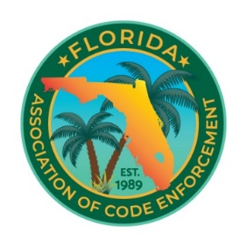

Florida Association of Code Enforcement
Board of Directors Virtual Meeting
September 17, 2024 at 1:00 PM – 3:00 P.M

- Call to Order

- Roll Call

- Welcome Guest

- Approval of Agenda

- Approval of minutes
1. July 12, 2024

- Treasurer Report (Mr. Johnson / Mr. Acosta)

- Old Business
1. Training Review / Update (Mr. Martin / IOG)
2. Florida Public Safety Academy (Mr. Martin)

- New Business
1. Public Records Request (Mr. Durham)
2. Association Computers (Mr. Hooker)
3. Accreditation Change (Mr. Hoagland)
4. Conference Update (Ms. Bonin)
5. Committee Updates (Board of Directors)

- Good For the Organization -

